## Week3





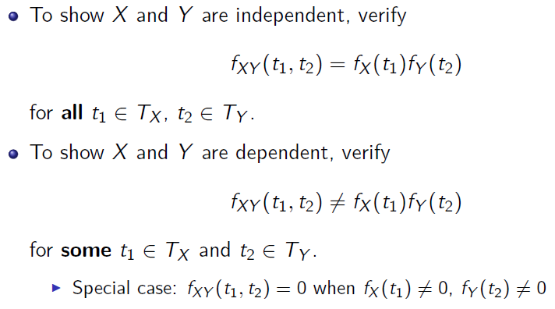

In the case of Geometric distribution

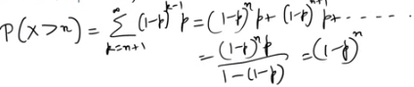

Memoryless property of Geometric





If X1 = Binomial (n1, p) and X2 = Binomial (n2, p), conditional probability mass function of X1 given that X1 + X2 = m is HyperGeo(n1 + n2, n1, m)

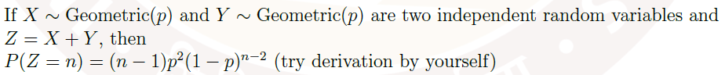



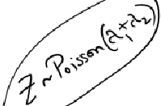

## Week4

Properties of Expectation and Variance of random variables

E[cX] = cE[X]

E[X + Y] = E[X] + E[Y]

E[aX + bY] = aE[X] + bE[Y]





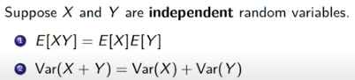

Covariance and Correlation coefficient



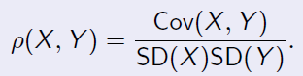

Properties of CDF of a continuous random variable X:

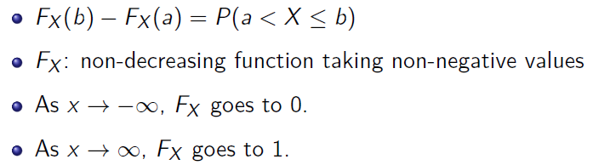



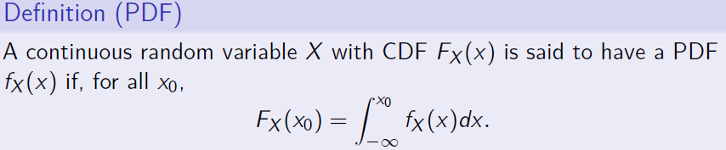

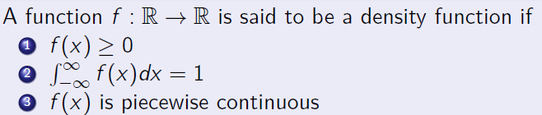

In the case of most distributions – exponential, uniform – PDF can be obtained by integrating the CDF. However, in the case of normal distribution, it’s very difficult to integrate and hence the need to standardize the PDF expression to obtain the Z-score and use the Z-table to find the PDF.

Here’s an example:

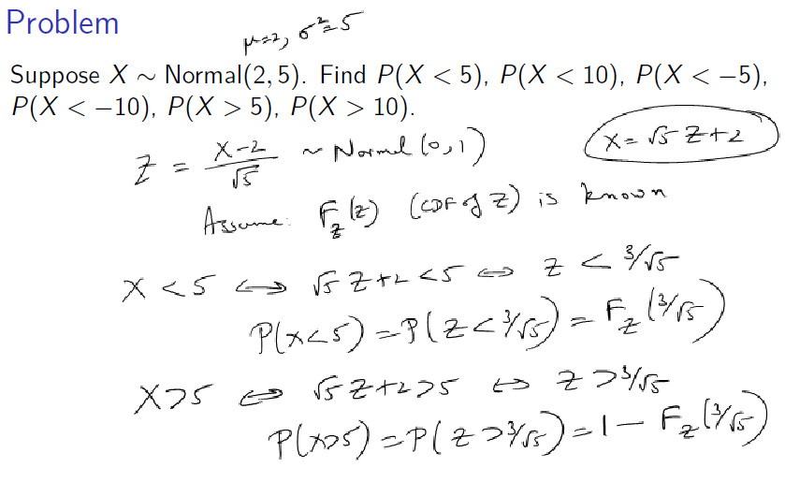

## Week7

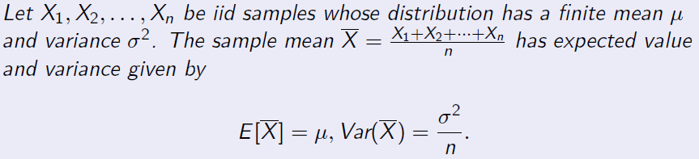

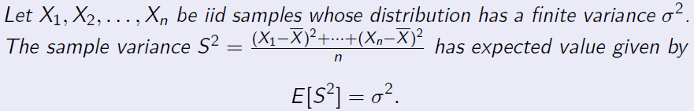



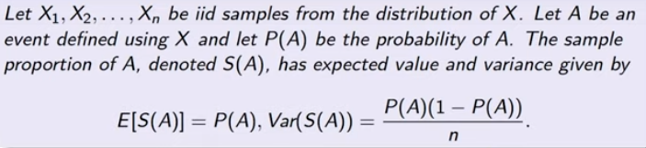

If we take multiple samplings, by the previous result we know  . But each sampling can have different mean and not necessarily equal to μ. The difference is given by WLLN. It’s not exact, but a good bound.



It also implies the following:



The WLLN can be improved by using an exponential bound (Chernov)



Here S is the sum of the random variables. Note S/n =

Here’s an application of the above two bounds (WLLN and Chernov) to Binomial (n, ½).

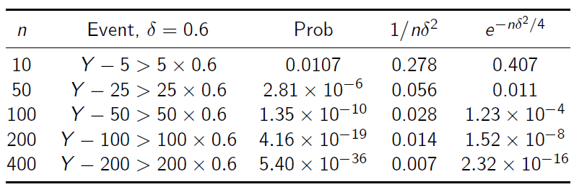

Notice the Chernov bound is closer to the actual Probability (third column in the table)



Use this to find the distribution of the sum of random variables. Here’s some examples.



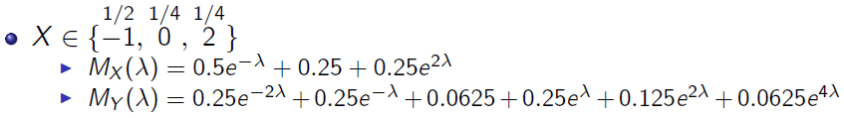

The resulting distribution is given here. 

MGF of a random variable X (with zero mean) is defined as 

MGF of random variable X in {x1, x2, … ,xn} is defined as

*  , when discrete
* 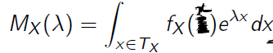 when continuous.

Why is it called moment-generating function?

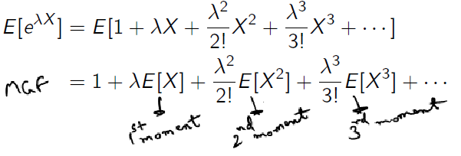

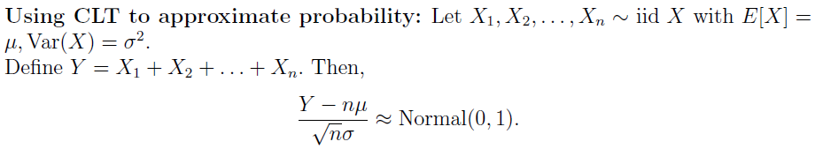



Here’re two examples of application of CLT.

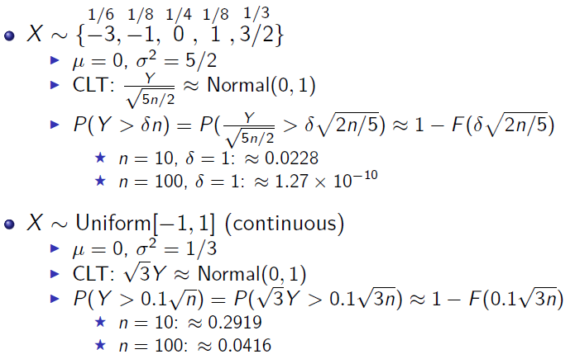







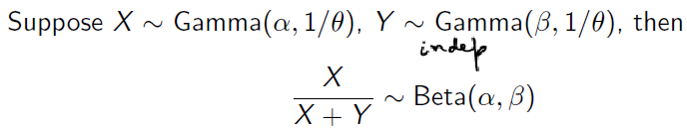



This is because…

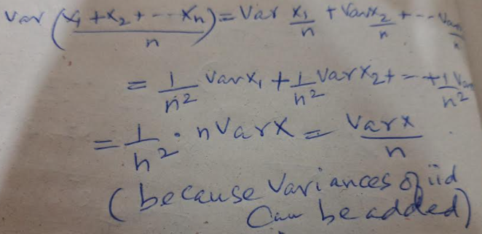

## Week8





. It is called *mean* *squared-error* (MSE) or *second moment of error*.



Method of moments estimation procedure

1. We’ll start with the assumption that Sample moments(m1, m2..) = distribution moments(M1, M2,…)
2. Calculate sample moments. m1 = , m2 = . Note that m2 is needed only if you’re doing computations with variance.
3. Find distribution moments from the predefined formulae for the distribution. For example, in the case of Bernoulli M1 = p, in the case of Exponential(λ) M1 = 1/λ
4. Now, equate these two. Estimate p or λ in terms of m1. If we’ve multiple parameters to estimate, use m2, m3 etc.

## Week9

Start with a random variable p is Uniform{0.25, 0.75} (called prior). We’re trying to estimate p, by looking a sample

S = 1, 0, 1, 1, 0

There are two possible Bayesian estimators





where,

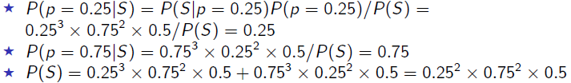

Now, if we were to change the prior distribution, the resulting estimate of p changes.

In general, this is written as

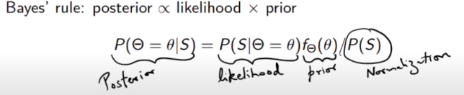

Estimating p for Bernoulli(p) samples:

1. If you choose  as the prior, the posterior density is  and the posterior mean is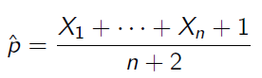

2. If you choose as the prior, the posterior density is and the posterior mean is

NOTE1: if α = 1 and β = 1, you get the same equation as the first one where prior is uniform.

NOTE2: if α = 0 and β = 0, you get posterior mean as the maximum likelihood.

Estimating μ for Normal (μ, σ2) samples, when σ2 is known.

If you choose  as the prior, the posterior mean is 

Here’s a sample problem of estimation using MME, ML and Bayesian methods:

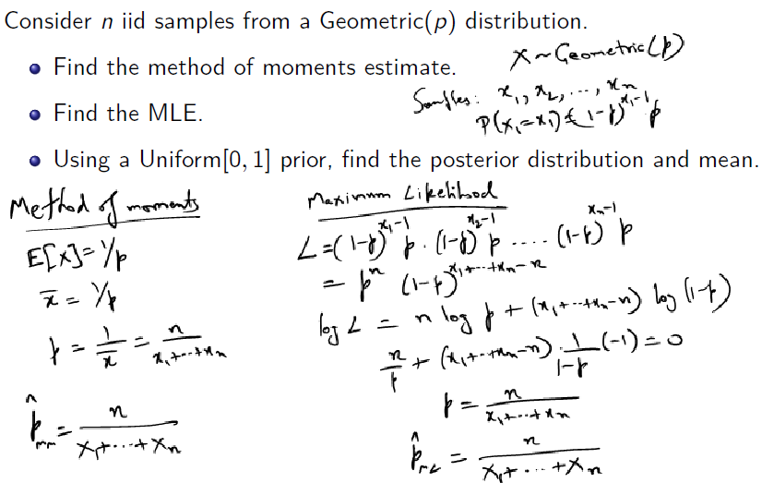

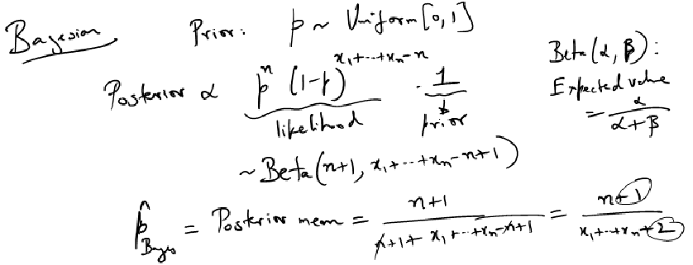

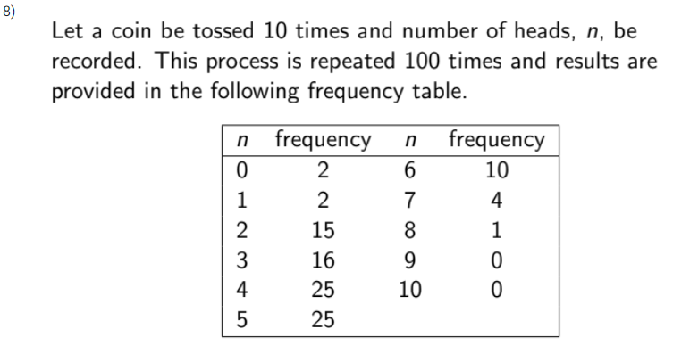

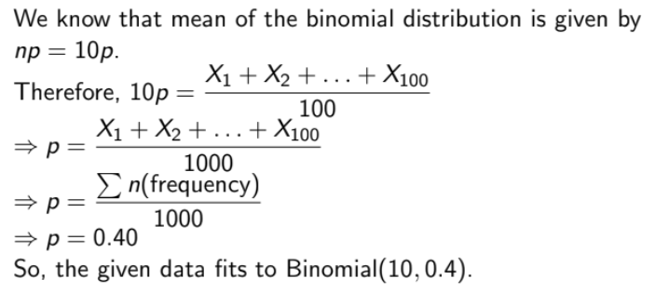



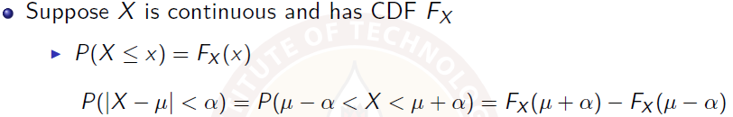

If distribution of X is symmetric about its mean, then 

For normal samples,





Here is the table we use to arrive at the alpha value, from a given beta.

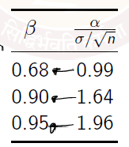

This is explained in *Miscellanous Problems.docx* under *Solve with us-8* section.

## Week10

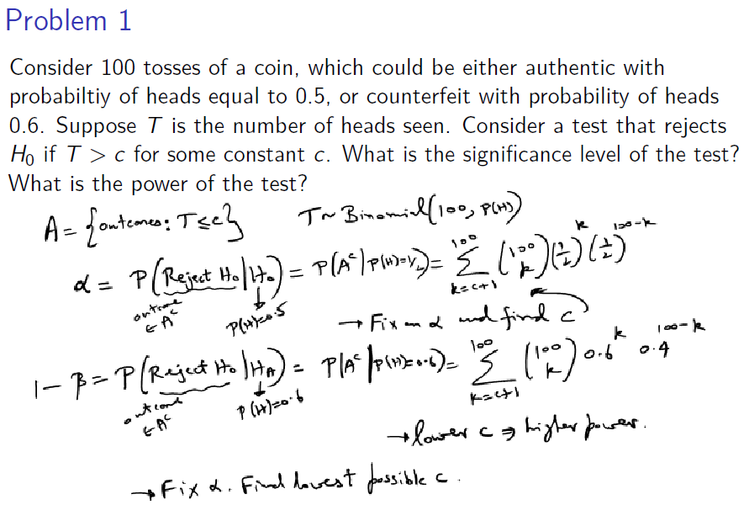

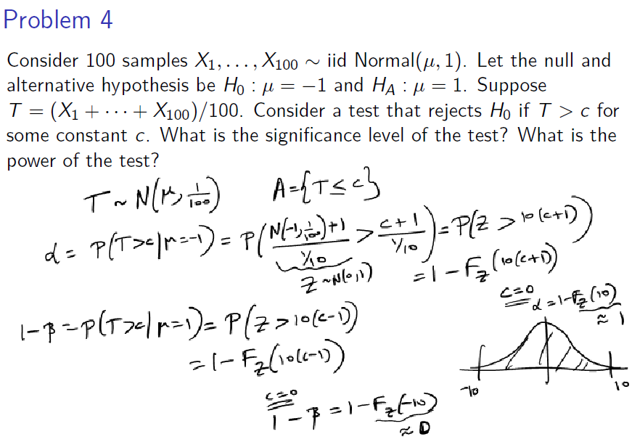

p-value or alpha?

